Sadsad, Dairnel Reese
Jingco, Jaspher

Week 3 Goal:
- Implement matching system
- Add lives + score
- Add start preview (5 sec)
- Make the game actually playable
- 5 lives total; 0 lives remaining = game over

Code:
import tkinter as tk
import random

root = tk.Tk()
root.title("Matching Card Game")
root.geometry("420x500")

ROWS = 4
COLS = 4

cards = []
buttons = []

first_card = None
second_card = None
lock = False
game_over = False

lives = 5
score = 0

info_label = tk.Label(root, text=f"Lives: {lives} Score: {score}", font=("Arial", 12))
info_label.pack(pady=10)

frame = tk.Frame(root)
frame.pack()

emoji_list = ["🐱", "🐸", "🍀", "💎", "🍭", "🍄", "⭐", "🔥",
"🎈", "🎨", "🏀", "🍕", "🚗", "🚀", "🎸", "👾",
"🤖", "👻", "🦄", "🌈", "🌞", "🍦", "🥥", "🦜"]

selected_emojis = random.sample(emoji_list, 8)
values = selected_emojis * 2
random.shuffle(values)

def update_ui():
info_label.config(text=f"Lives: {lives} Score: {score}")

def hide_cards():
for i in range(len(cards)):
if not cards[i]["revealed"]:
buttons[i].config(text="?", bg="SystemButtonFace")

def start_preview():
for i in range(len(cards)):
buttons[i].config(text=cards[i]["value"], bg="light blue")

root.after(5000, hide_cards)

def reset_turn():
global first_card, second_card, lock
first_card = None
second_card = None
lock = False

def end_game():
global game_over
game_over = True

for i in range(len(cards)):
buttons[i].config(text=cards[i]["value"], bg="lightgray")

info_label.config(text="Game Over! You Lost.")

def check_match():
global lives, score

if first_card["value"] == second_card["value"]:
score += 1
update_ui()
reset_turn()
else:
lives -= 1
update_ui()

if lives == 0:
end_game()
return

def flip_back():
first_card["revealed"] = False
second_card["revealed"] = False

buttons[first_card["index"]].config(text="?", bg="SystemButtonFace")
buttons[second_card["index"]].config(text="?", bg="SystemButtonFace")

reset_turn()

root.after(1000, flip_back)

def on_card_click(index):
global first_card, second_card, lock

if lock or game_over:
return

card = cards[index]

if card["revealed"]:
return

card["revealed"] = True
buttons[index].config(text=card["value"], bg="light blue")

if first_card is None:
first_card = card
elif second_card is None:
second_card = card
lock = True
check_match()

for i in range(ROWS * COLS):
card = {
"value": values[i],
"revealed": False,
"index": i
}
cards.append(card)

for i in range(ROWS):
for j in range(COLS):
index = i * COLS + j

btn = tk.Button(
frame,
text="?",
width=8,
height=4,
command=lambda idx=index: on_card_click(idx)
)

btn.grid(row=i, column=j, padx=5, pady=5)
buttons.append(btn)

root.after(500, start_preview)

root.mainloop()

Screenshots:
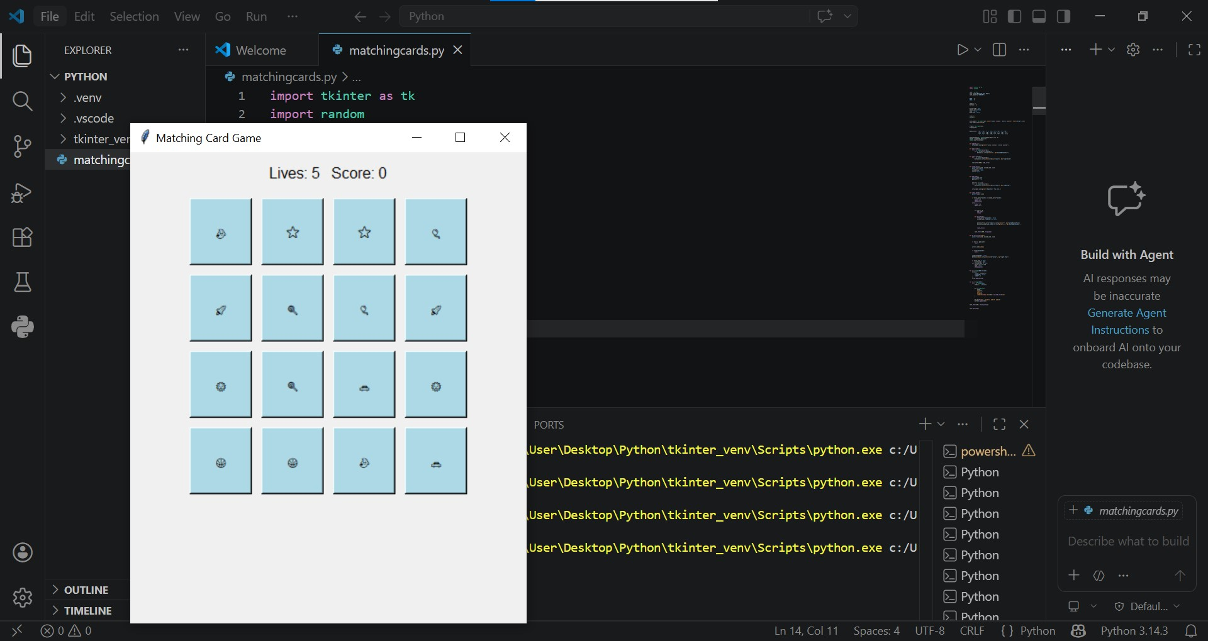

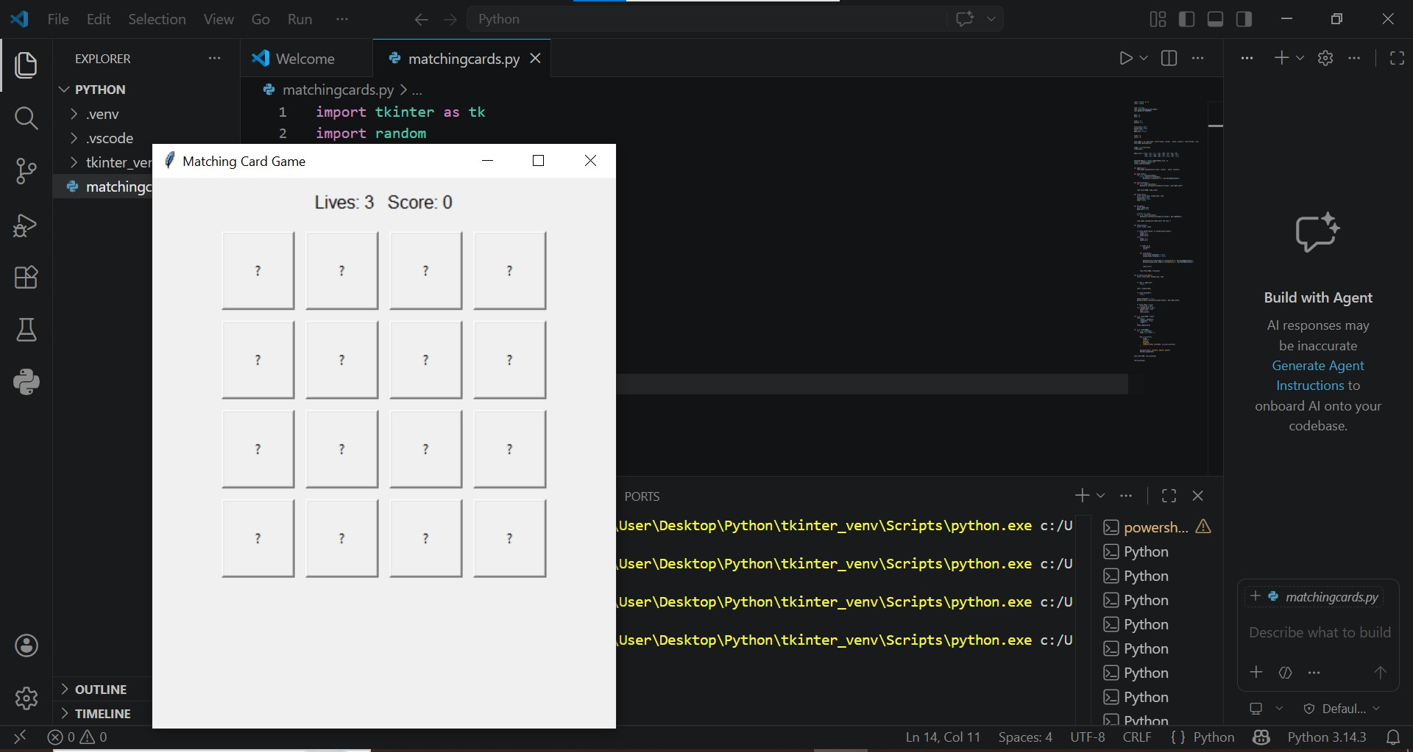

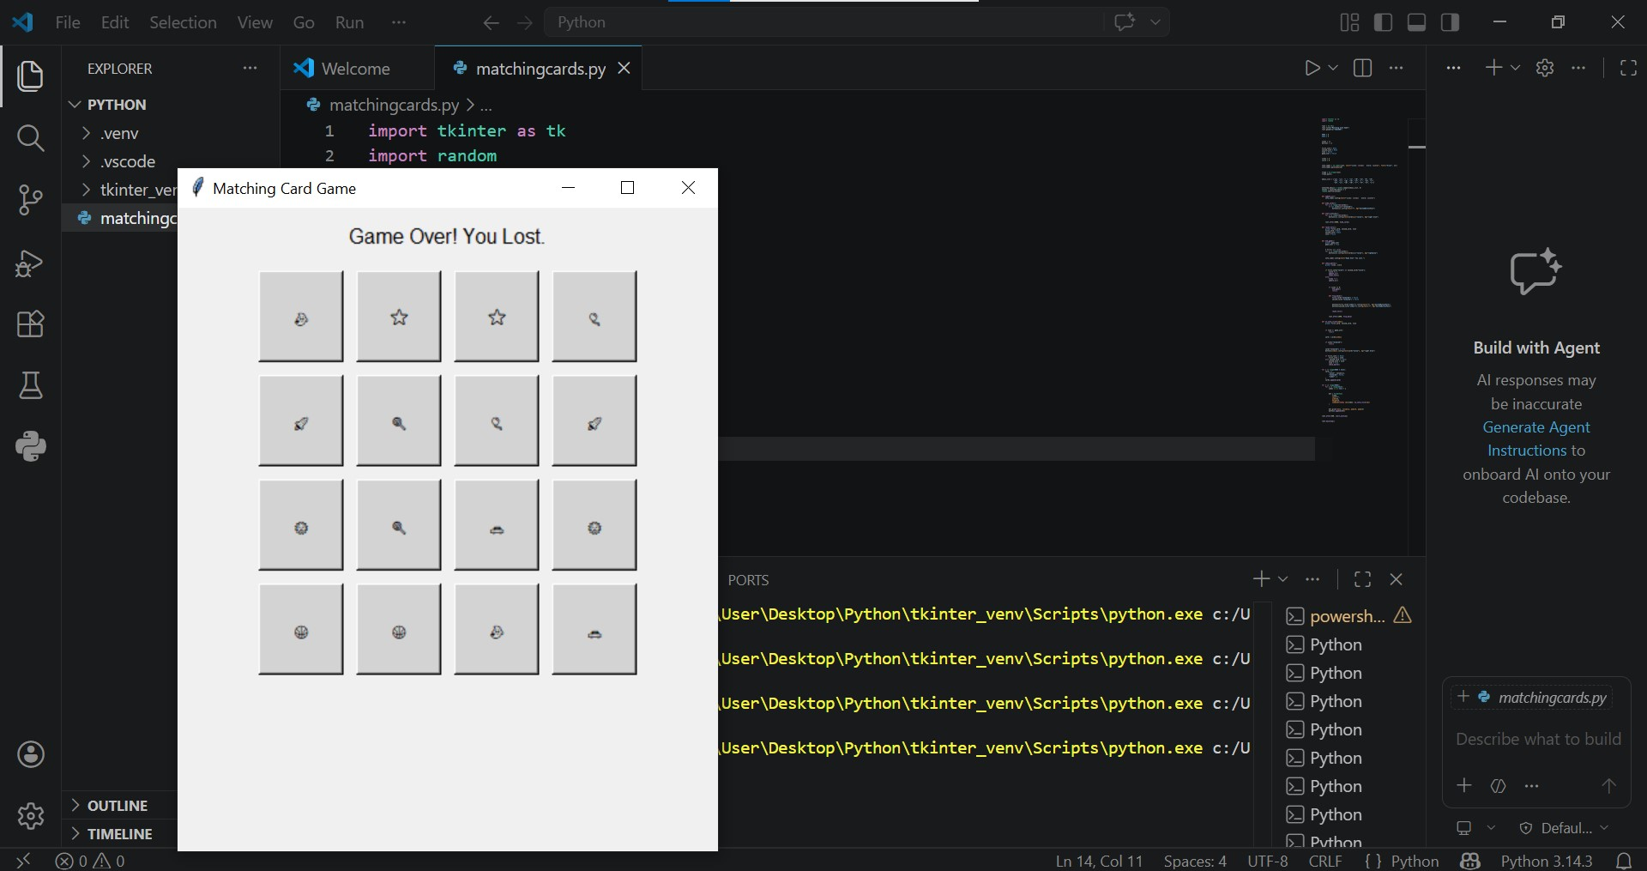

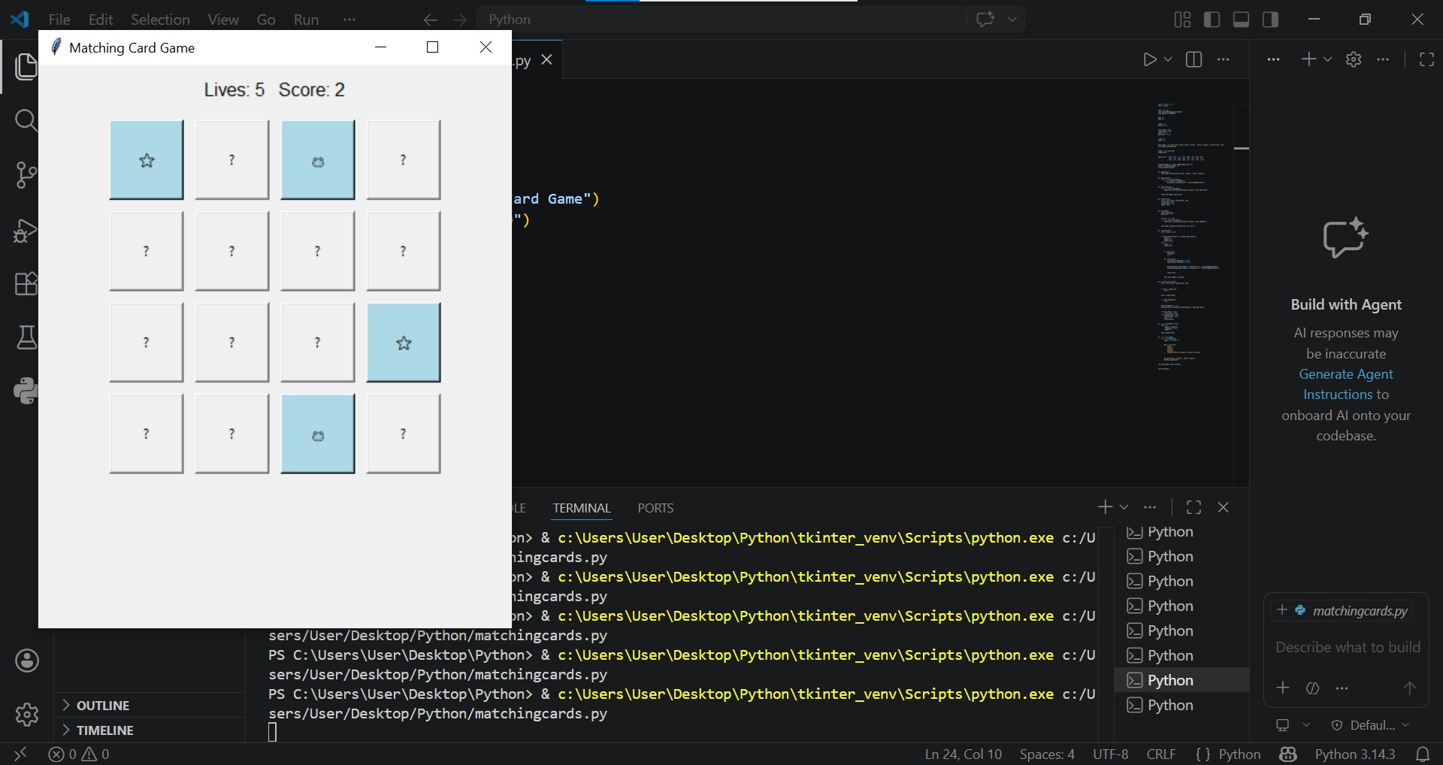

Summary:

From the week 2 submission, the cards are now changed into emojis. For now, eight random emojis are selected then placed once the game starts. The goal is to build a fully playable card-matching game by the end of the week. The game will include a matching system, a scoring mechanism, and a lives feature has been improved to stop when lives run out. Starting with 5 lives and ending when all lives are lost. A 5-second preview at the start will briefly show all cards before gameplay begins. Card pairs are now created using emojis and shuffled randomly. The system will track the first and second selected cards, then check if they match. If the cards do not match, they will flip back after a short delay using a timed function.

Week 4 Progress:

import tkinter as tk
from tkinter import messagebox
import random

class Card:
def __init__(self, value, color="#93a1a1"):
self.value = value
self.front_bg = color
self.back_bg = "#073642"

class NormalCard(Card):
def __init__(self, value): super().__init__(value, "#eee8d5")

class HeartCard(Card):
def __init__(self): super().__init__("❤️", "#dc322f")
def activate_effect(self, game):
game.lives += 1
game.update_status()

class TornadoCard(Card):
def __init__(self): super().__init__("🌪️", "#6c71c4")
def activate_effect(self, game):
game.show_alert("🌪️ TORNADO! 🌪️", "#6c71c4")
game.animate_tornado(steps=15)

class PeekCard(Card):
def __init__(self): super().__init__("👁️", "#b58900")
def activate_effect(self, game):
game.show_alert("👁️ PEEKING... 👁️", "#b58900")
game.full_board_peek(3000)

class MemoryGame:
def __init__(self, root):
self.root = root
self.root.title("Chaos Memory: Ultimate UI")

self.sol_bg = "#d3d3d3"
self.sol_header = "#d3d3d3"
self.sol_text = "#93a1a1"
self.match_color = "#859900"
self.miss_color = "#dc322f"

self.root.configure(bg=self.sol_bg)
self.root.geometry("1250x980")

self.lives = 5
self.score = 0
self.level = 1
self.is_processing = False
self.first_selection = None
self.cards = []
self.buttons = []

self.setup_ui()
self.load_level(1)

def setup_ui(self):

self.header_frame = tk.Frame(self.root, bg=self.sol_header, pady=20)
self.header_frame.pack(fill="x")
for i in range(3): self.header_frame.grid_columnconfigure(i, weight=1)

self.status_label = tk.Label(self.header_frame, text="", font=("Verdana", 14, "bold"),
bg=self.sol_header, fg=self.sol_text, anchor="w")
self.status_label.grid(row=0, column=0, padx=20, sticky="w")

self.alert_label = tk.Label(self.header_frame, text="", font=("Verdana", 18, "bold italic"),
bg=self.sol_header, fg="#6c71c4")
self.alert_label.grid(row=0, column=1)

self.right_frame = tk.Frame(self.header_frame, bg=self.sol_header)
self.right_frame.grid(row=0, column=2, padx=20, sticky="e")

self.peek_btn = tk.Button(self.right_frame, text="SHOW ALL", font=("Arial", 9, "bold"),
bg="#b58900", fg="#fdf6e3", relief="flat", padx=10, pady=5,
command=lambda: self.full_board_peek(2000))
self.peek_btn.pack(side="left", padx=10)

self.lives_label = tk.Label(self.right_frame, text="", font=("Arial", 16),
bg=self.sol_header, fg="#dc322f")
self.lives_label.pack(side="left", padx=10)

self.board = tk.Frame(self.root, bg=self.sol_bg)
self.board.pack(expand=True, pady=10)

self.progress_frame = tk.Frame(self.root, bg=self.sol_header, height=10)
self.progress_frame.pack(fill="x", side="bottom")
self.progress_bar = tk.Frame(self.progress_frame, bg=self.match_color, width=0, height=10)
self.progress_bar.place(x=0, y=0)

def load_level(self, lvl):
self.level = lvl
config = {1: (42, 18, 7), 2: (48, 21, 8), 3: (54, 24, 9)}
total, pairs, cols = config[lvl]
self.current_cols = cols
self.total_pairs = pairs
self.pairs_found = 0

emojis = ["🐬", "🍕", "🎁", "🤪", "🦁", "🔒", "🌻", "🥳", "🐕", "🍒", "🔥", "🚀", "🌈", "🍦", "🎨", "🥑", "🍄", "👾"]
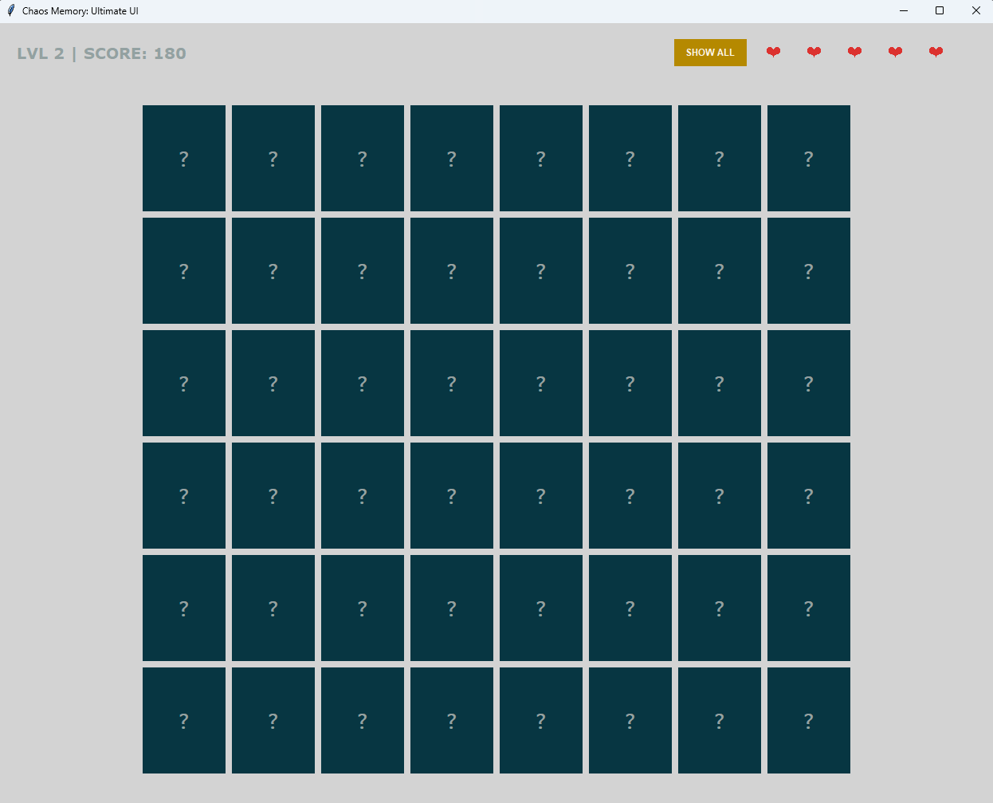

Summary:
We are currently in the process of finalizing the color palette for our custom emojis to ensure they align perfectly with our brand identity. While the core designs are ready, we are still determining the specific hex codes and tonal variations that will provide the best visual balance and contrast across different themes. Once these selections are confirmed, we will implement the final color values across the entire set.

